Introduction to Information Security - CS 458 - Spring 2019

Lab 1 - Secret-Key Encryption

Due: Blackboard Sunday February 24th, 2019 by 11:59pm

2 Lab Tasks

2.1 Task 1: Frequency Analysis Against Monoalphabetic Substitution Cipher

Using Python

1. Most frequent English letters: e t a o i n s
2. 1-letter English words: a i
3. Most frequently doubled letters in English: s e t f l m o
4. Most frequent 2-letter words in English: an, at, as, he, be, in, is, it, on, or, to, of, do, go, no, so, my
5. Most frequent 3-letter words in English: the, and, for, was, his, not, but, you, are, her
6. Most frequent initial letters in English: t a s o i
7. Most frequent ﬁnal letters in English: e s d n t

Plaintext Substitution:

1. Frequency analysis is done through Python and steps are identified.
2. Result:

'COMPUTER SCIENCE IS RAPIDLY CHANGING THE WORLD WITH NEW DEVELOPMENTS HAPPENI NG EVERY DAY A RIGOROUS EDUCATION COMBINING THE THEORY OF INFORMATION AND COM PUTATION WITH HANDSON SYSTEMS AND SOFTWARE DESIGN IS THE KEY TO SUCCESS AS ON E OF THE OLDEST COMPUTER SCIENCE DEPARTMENTS IN THE CHICAGO AREA THE CS DEPAR TMENT AT IIT HAS A LONG HISTORY OF MEETING THIS CHALLENGE THROUGH QUALITY EDU CATION IN SMALL CLASSROOM ENVIRONMENTS ALONG WITH INTERNSHIP AND RESEARCH OPP ORTUNITIES IN INDUSTRY AND NATIONAL LABORATORIESIIT STUDENTS WORK WITH OUR FA CULTY ON WORLDCLASS RESEARCH IN AREAS THAT INCLUDE DATA SCIENCE DISTRIBUTED S YSTEMS INFORMATION RETRIEVAL COMPUTER NETWORKING INTELLIGENT INFORMATION SYST EMS AND ALGORITHMS THE DEPARTMENT OFFERS BACHELOR OF SCIENCE MASTER OF SCIENC E PROFESSIONAL MASTER AND PHD DEGREES PLUS GRADUATE CERTIFICATES ACCELERATED COURSES AND NONDEGREE STUDY PARTTIME STUDENTS CAN TAKE EVENING CLASSES AND LO NGDISTANCE STUDENTS CAN EARN MASTERS DEGREES ONLINE STUDENTS RATE OUR TEACHIN G AS AMONG THE BEST AT THE UNIVERSITY AND OUR FACULTY HAVE WON NUMEROUS TEACHING AWARDS THE SECRET SENTENCE IS GOOD JOB GUYS'

2.2 Task 2: Encryption using Diﬀerent Ciphers and Modes

Set plain.txt to plaintext.txt and populated with the result of Task 1

3 Different ciphers and modes:

1. AES – 128 – CBC (Cipher: AES, Mode: CBC)

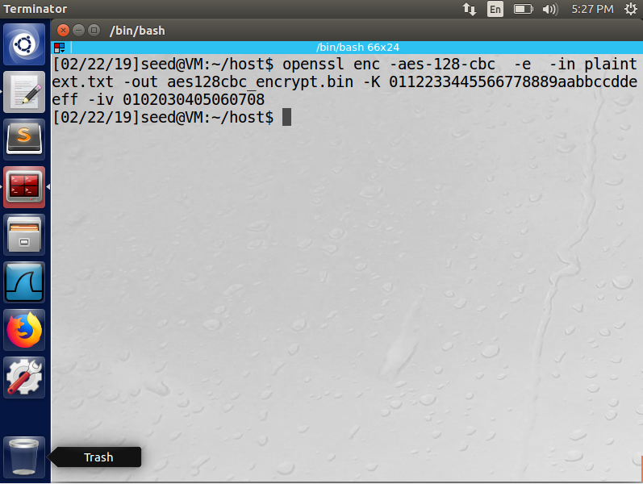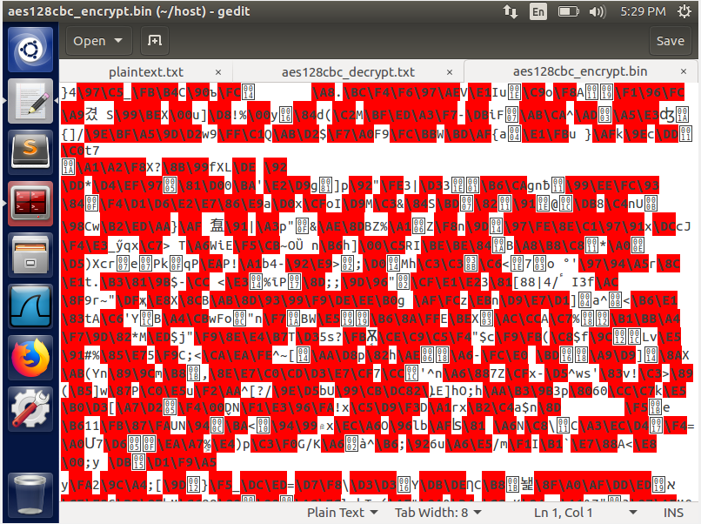

Command Encryption

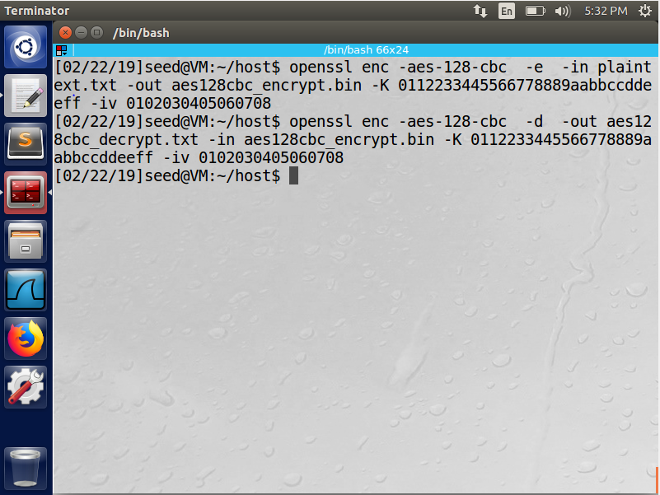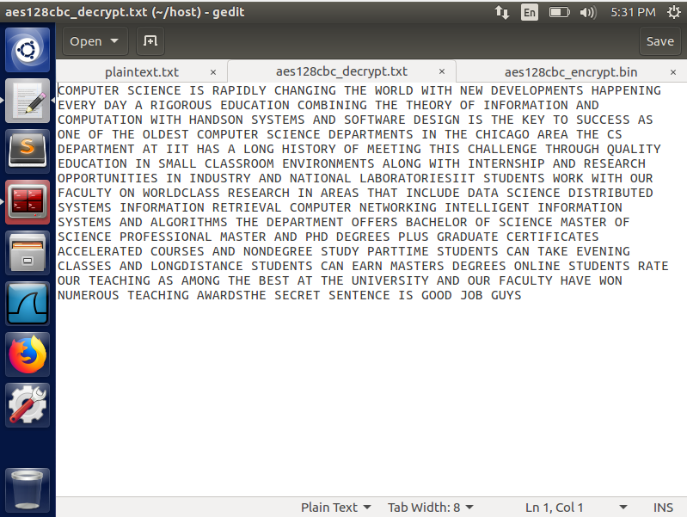

Command Decryption

1. DES (Cipher: DES, Mode: ?)

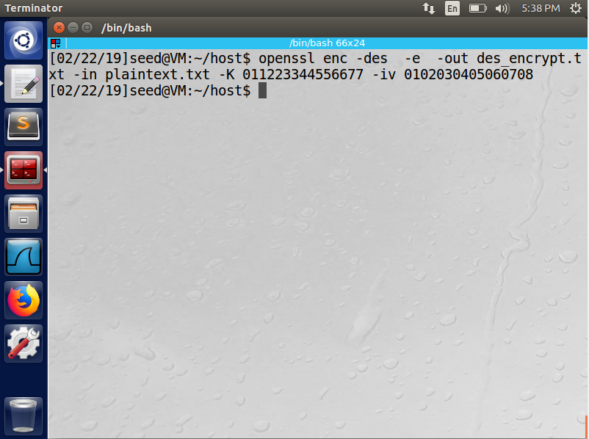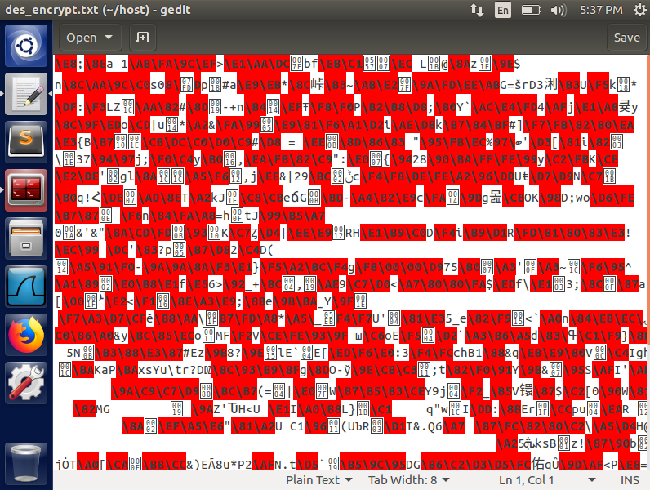

Command Encryption

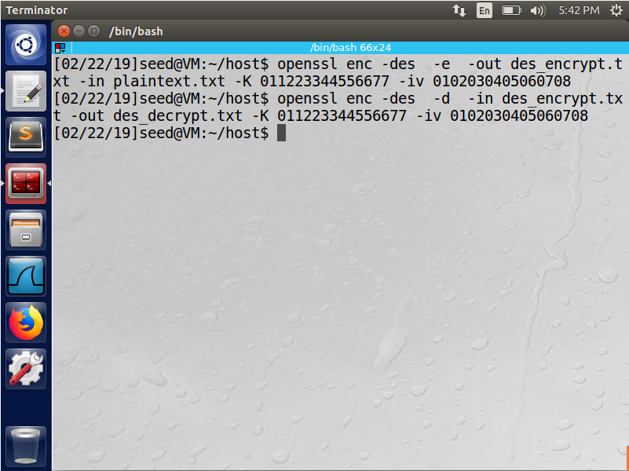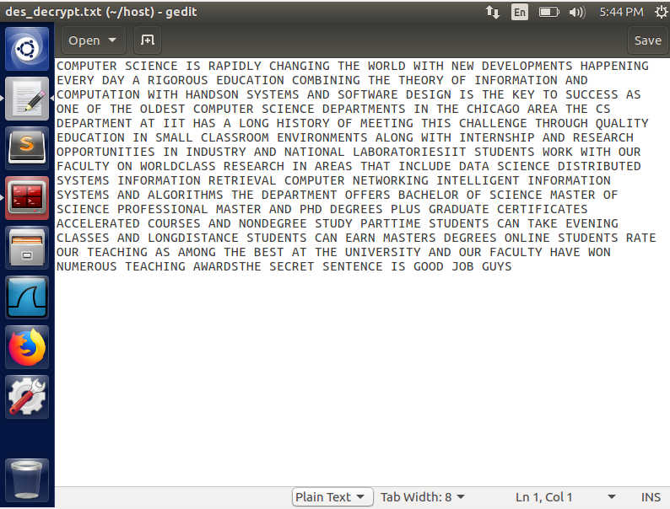

Command Decryption

1. Camellia-128-CBC (Cipher: Camellia, Mode: CBC)

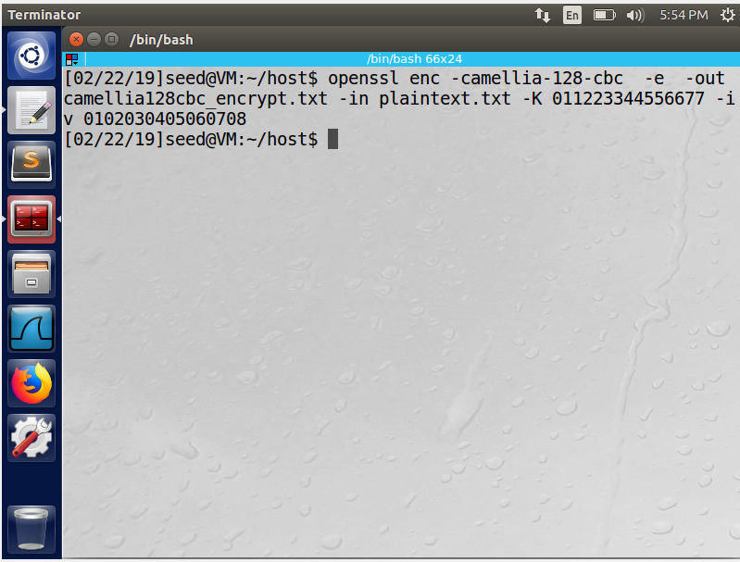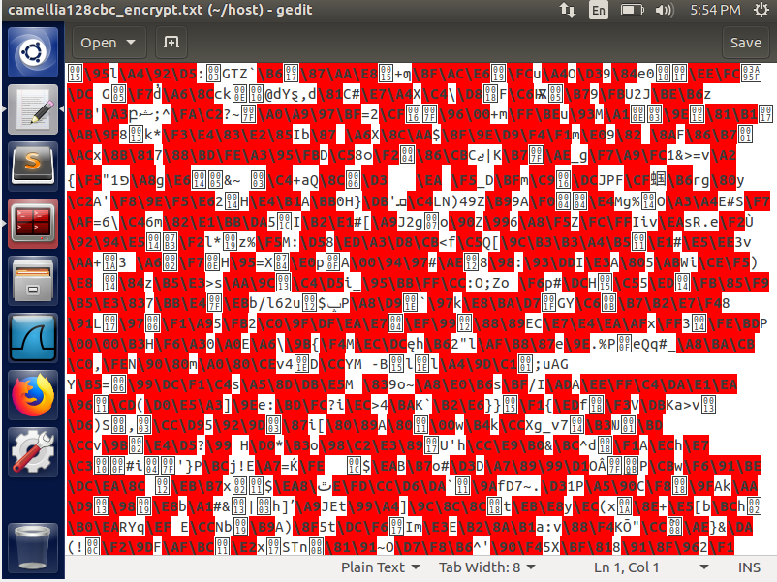

Command Encryption

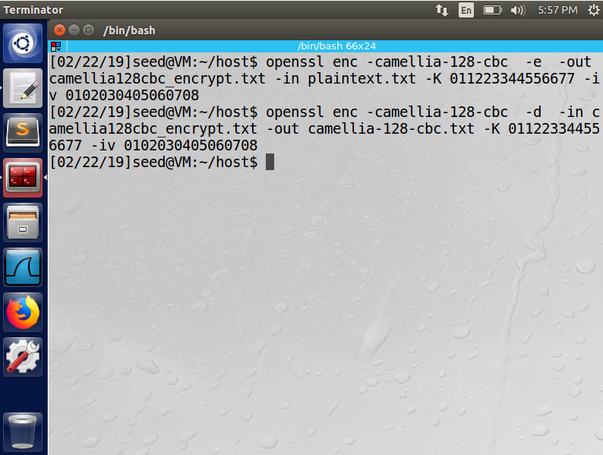 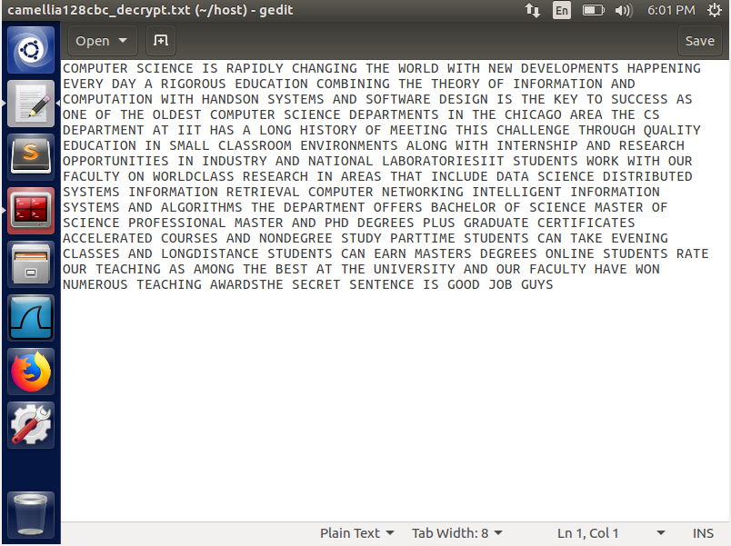

Command Decryption

1. DES-CFB (Cipher: DES, Mode: CFB)

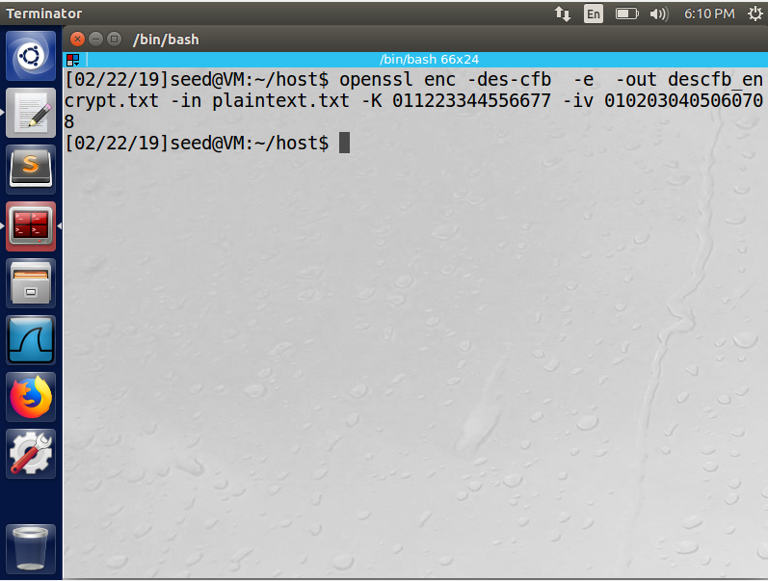 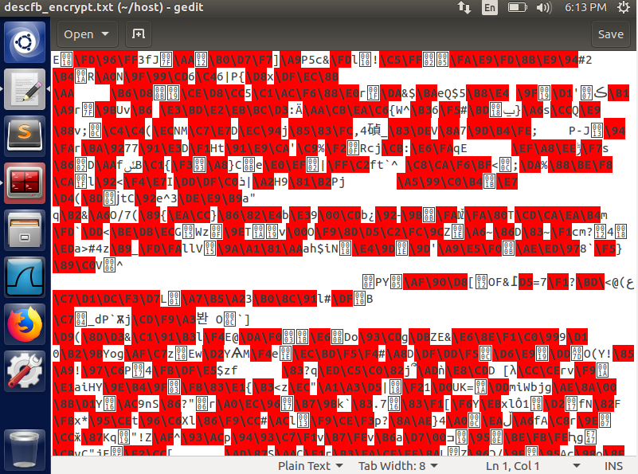

Command Encryption

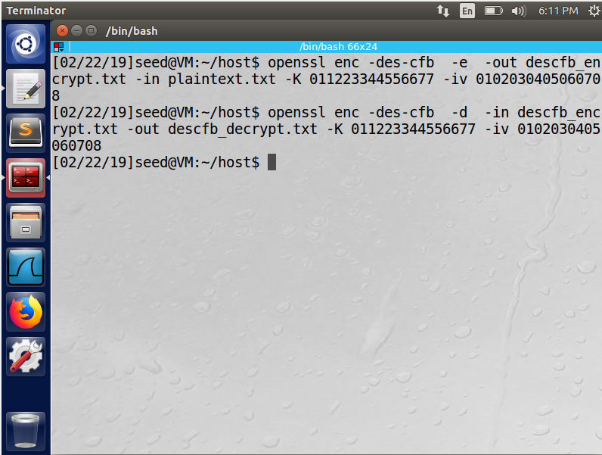 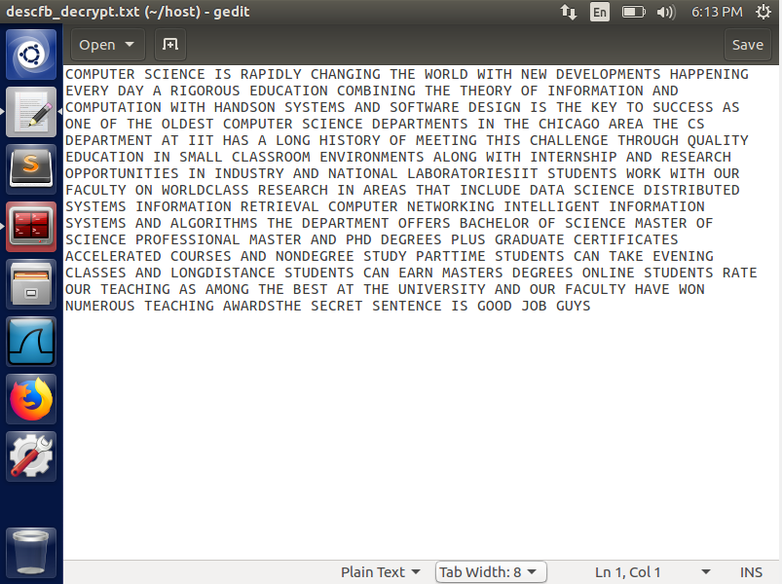

Command Decryption

1. DES-ECB (Cipher: DES, Mode: ECB)

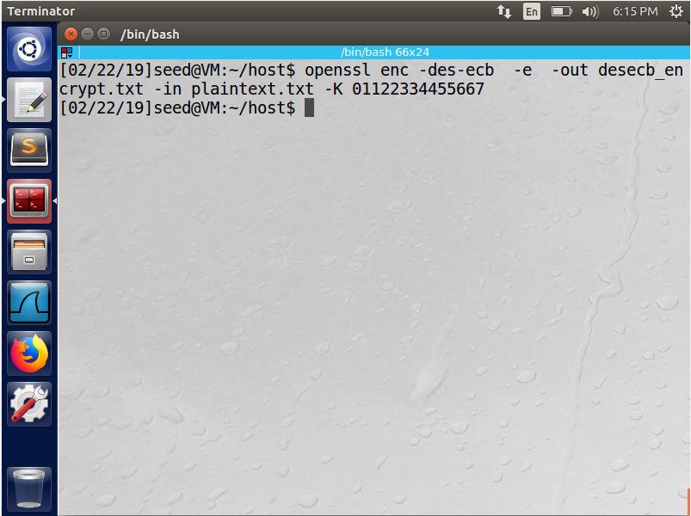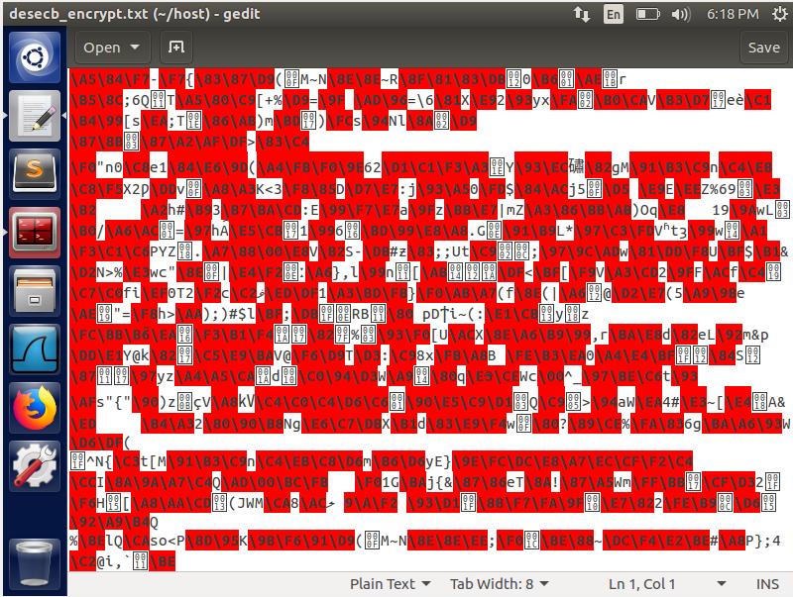

Command Encryption

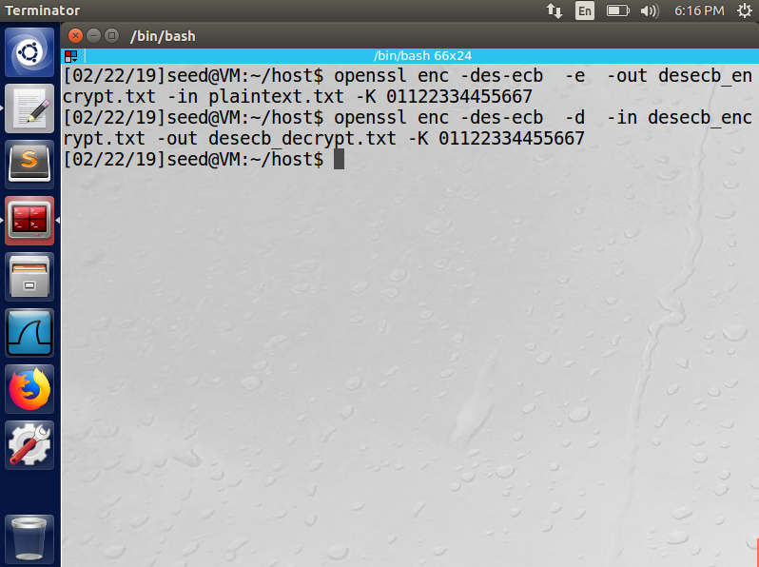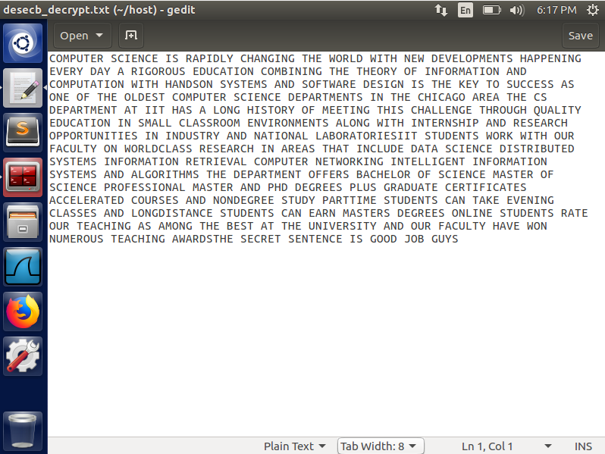

Command Decryption

2.3 Task 3: Encryption Mode – ECB vs. CBC

DES-CBC

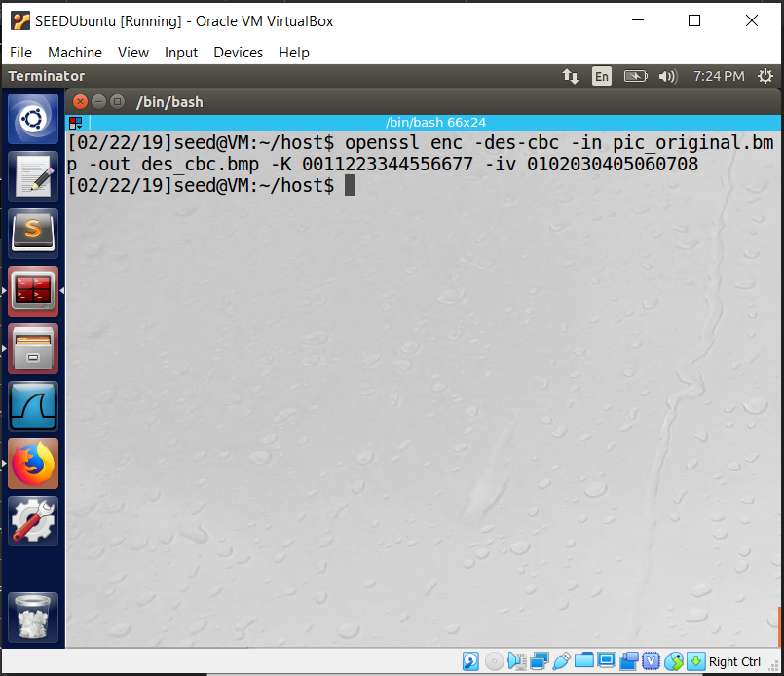

DES-ECB

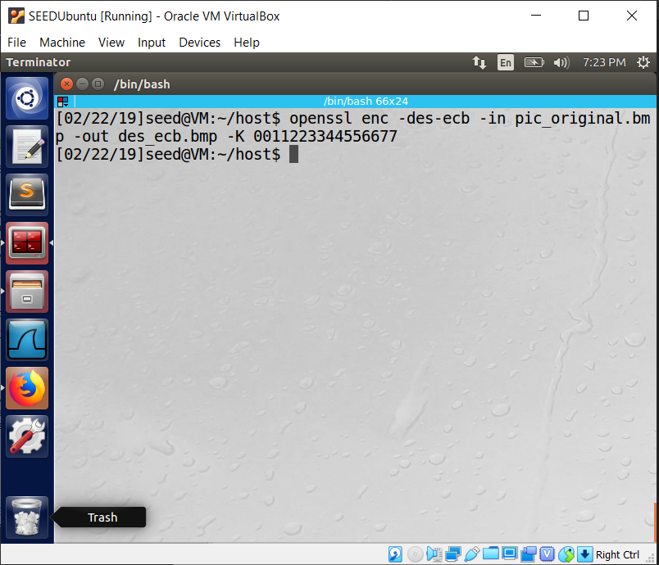

1. Command

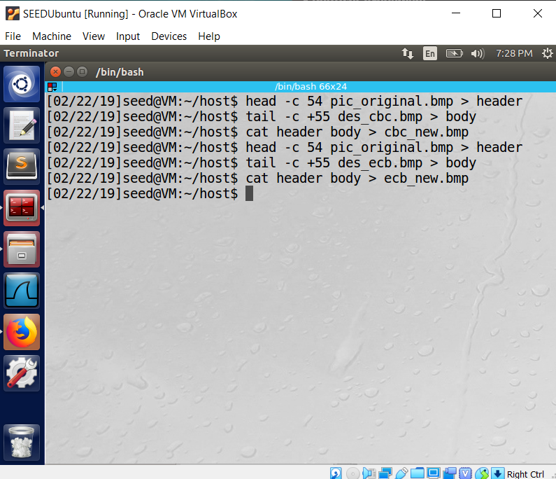

1. Original vs ECB

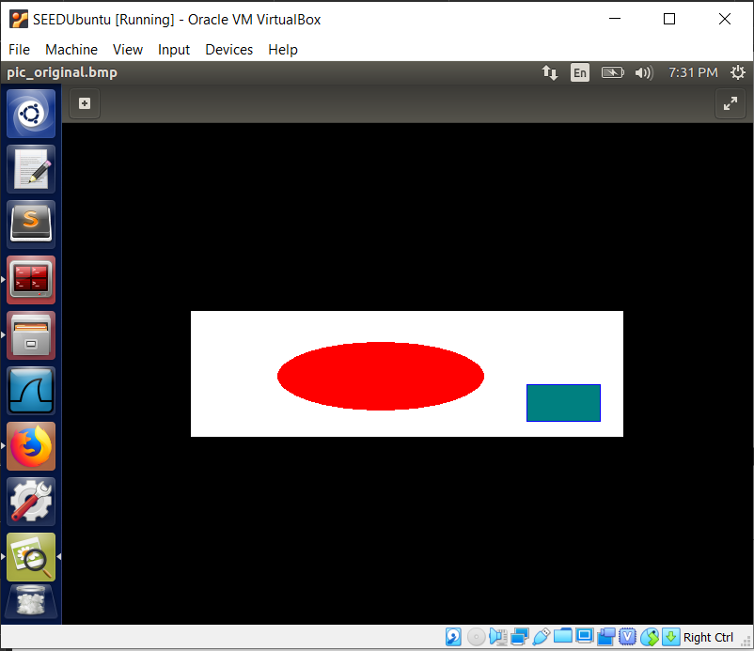 vs 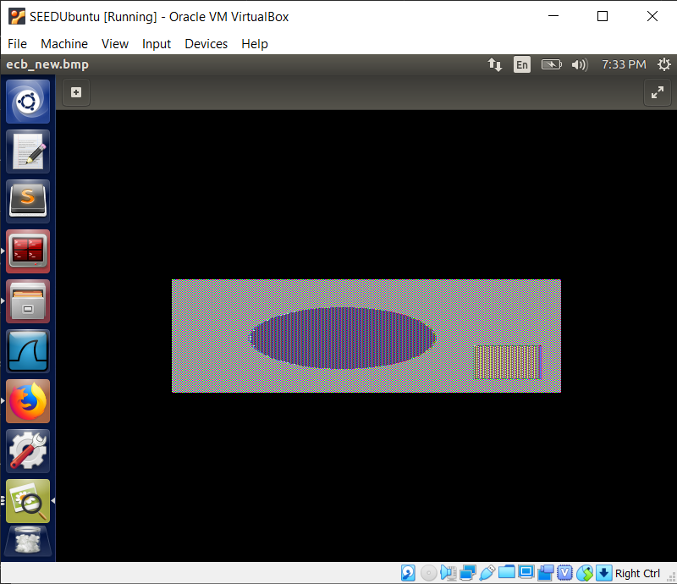

ECB mode seems to retain the shape of the original image but seems to be mirrored on the y-axis and the colors have been more dimmed.

Original vs CBC

 vs 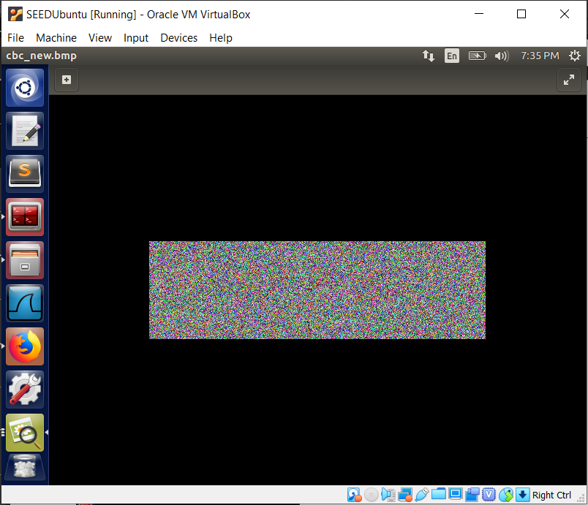

CBC has left the image full of noise even though a valid header is given, the original image cannot be retained.

Picture of your choice

Original vs ECB

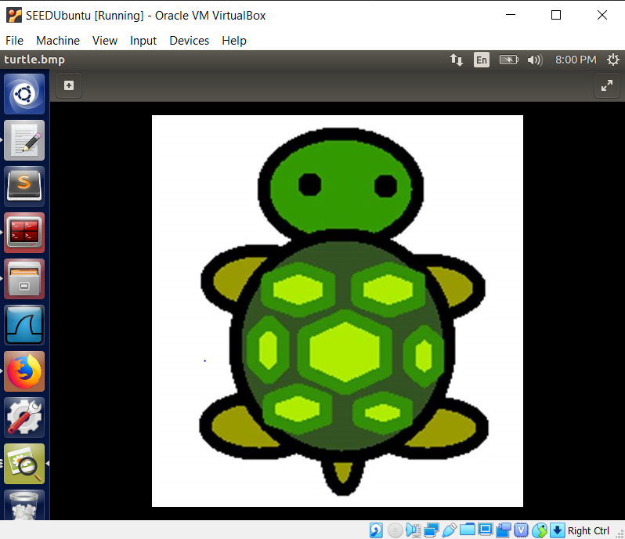 vs 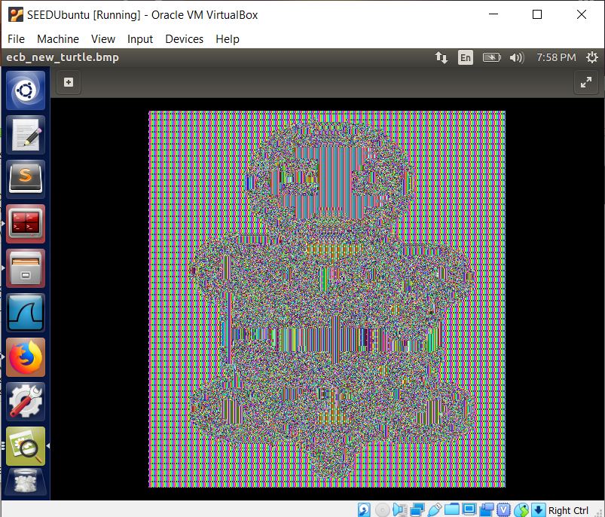

As before, the mutated ECB header image has retained the shape of the original image but mirroring of the y-axis cannot be evaluated.

Original vs CBC

 vs 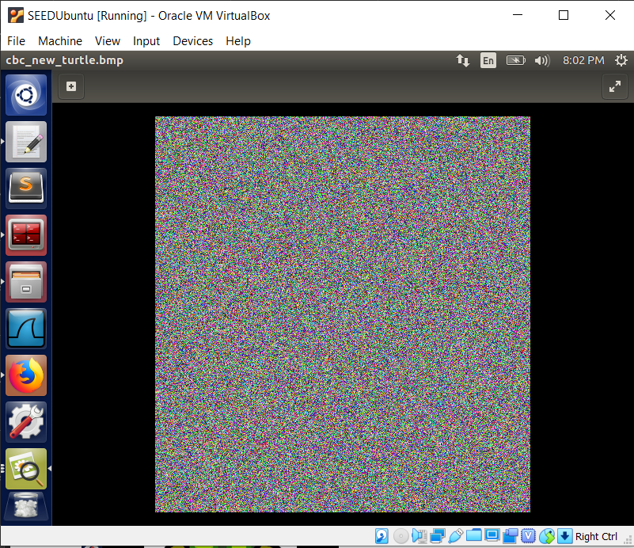

As before, the mutated CBC header image is filled with noise and the shape of the original is not preserved.

2.4 Task 4: Padding

1. Encryptions:

ECB CFB

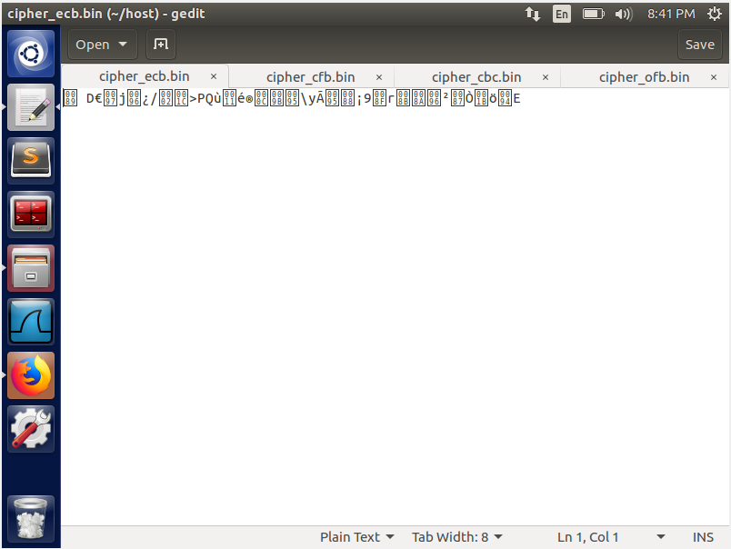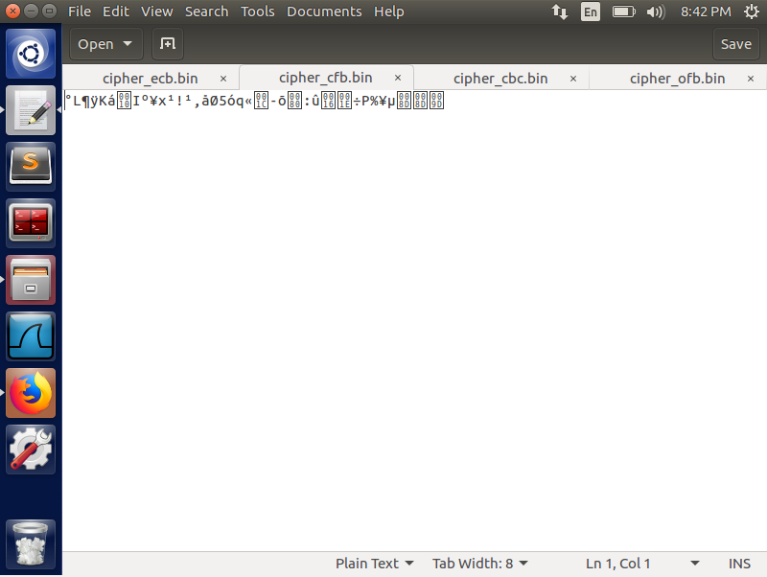

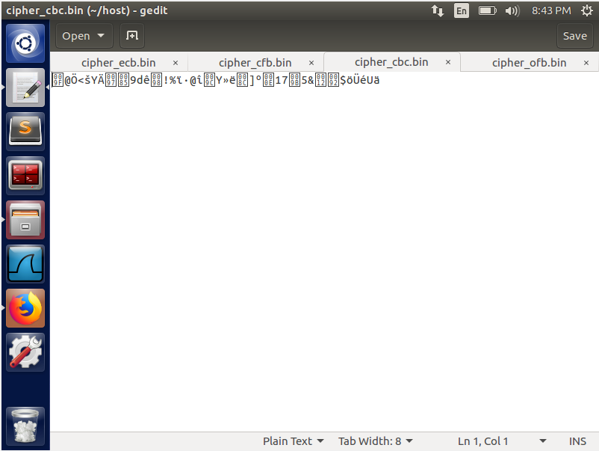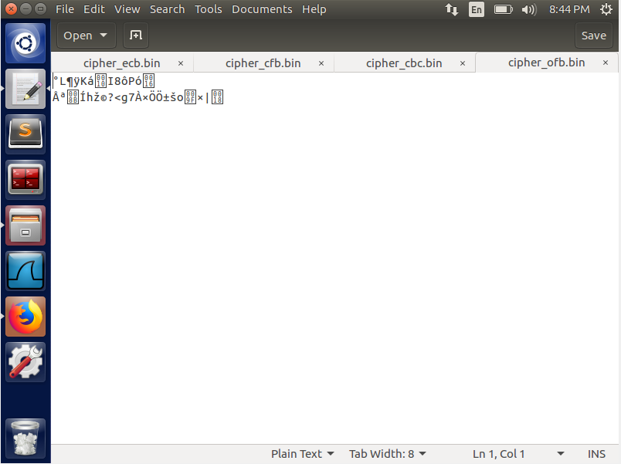

CBC OFB

The CBC and ECB modes has paddings while the CFB and OFB modes do not have paddings since OFB and CFB are using the block cipher as a stream cipher. Since these modes are XORs the plaintext and the block cipher which creates partial blocks.

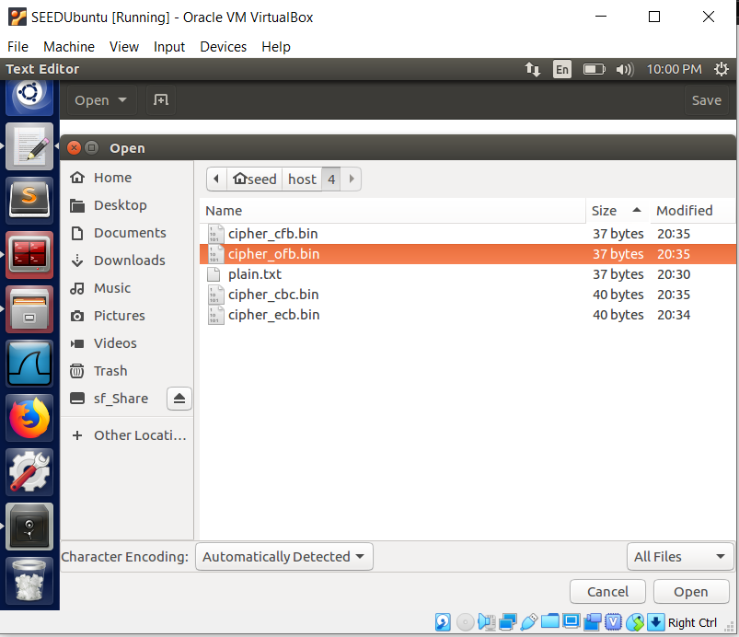

The file sizes also show that CBC and ECB growing in sizes due to padding.

1. Transformations:

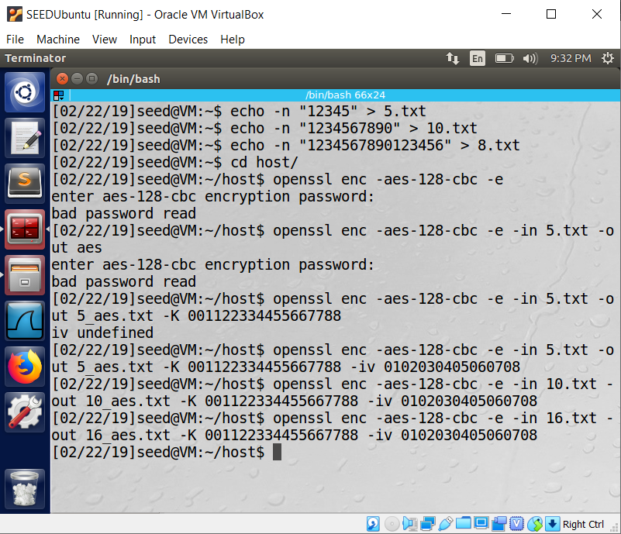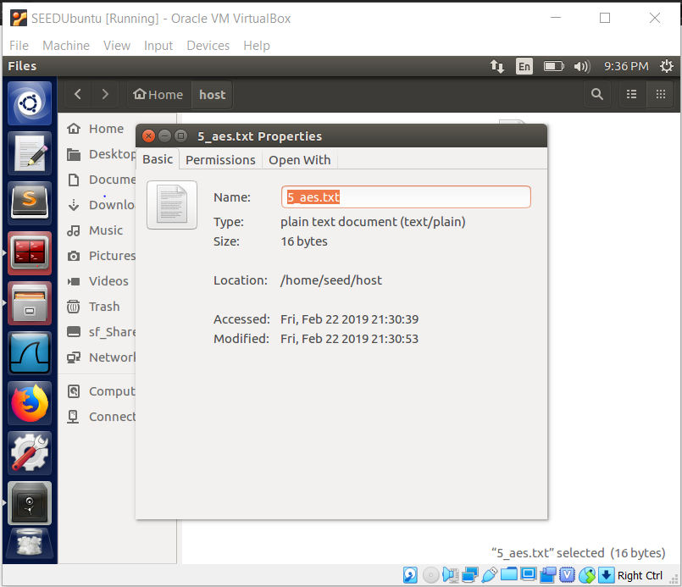

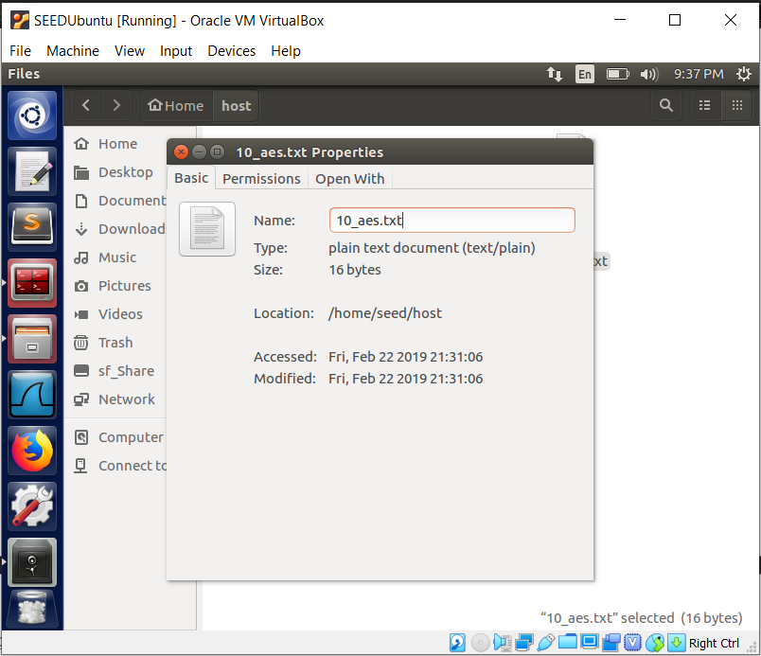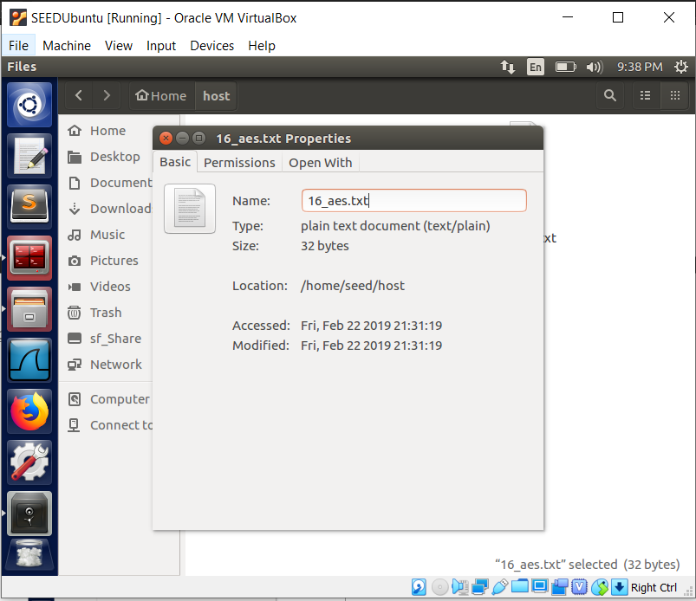

Both 5- and 10-byte encrypted files are 16 bytes while 16 byte file became 32 bytes.

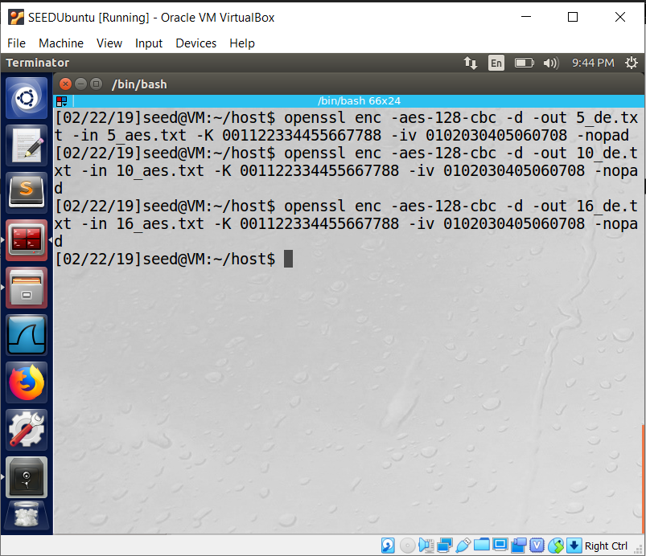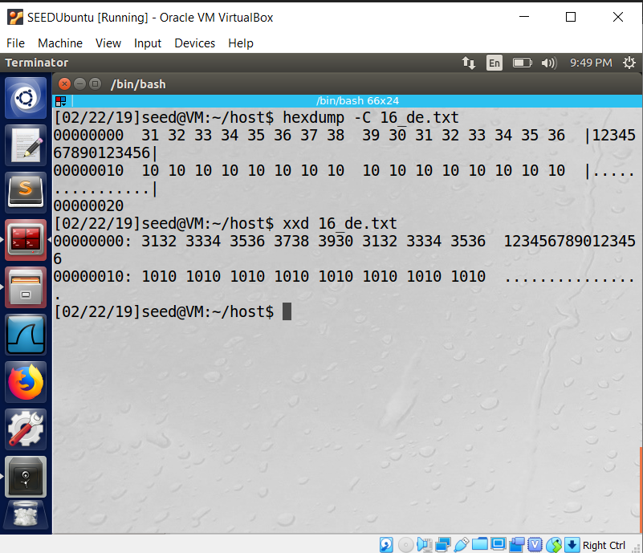

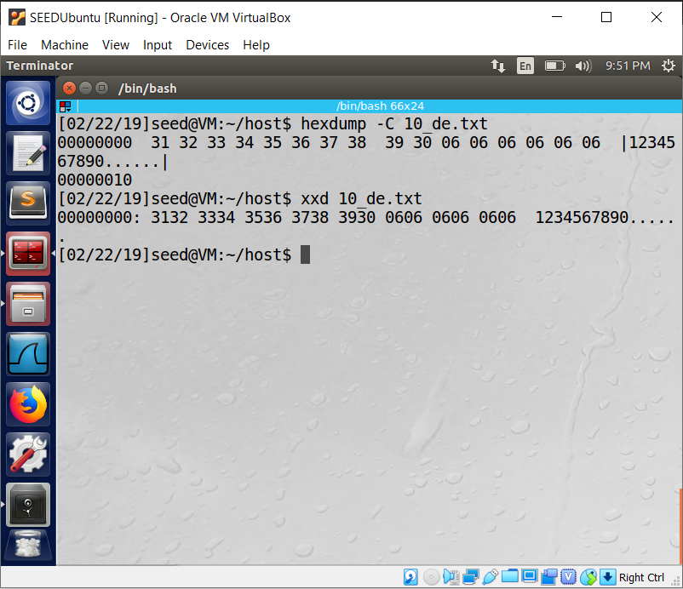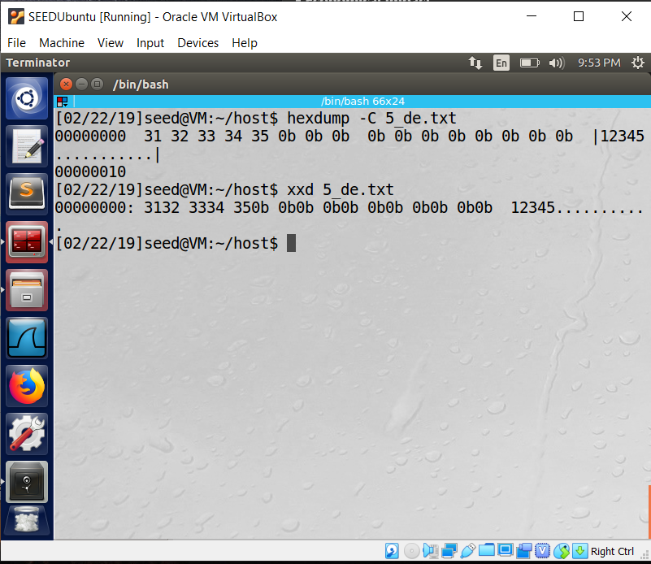

As seen above:

1. 0b (00001011) is added as padding at the end on the byte file 11 times (for 11 bytes = 16 bytes – 6 bytes) [11 = b]
2. 06 (00000110) is added as padding at the end on the byte file 6 times (for 6 bytes = 16 bytes – 10 bytes) [6 = 6]
3. 10 (00010000) is added as padding at the end on the byte file 16 times (for 16 bytes = 32 bytes – 16 bytes) [10 = 16 since 10 doesn’t exist in hex (it is a)]
   1. Task 5: Error Propagation – Corrupted Cipher Text
4. ,2.

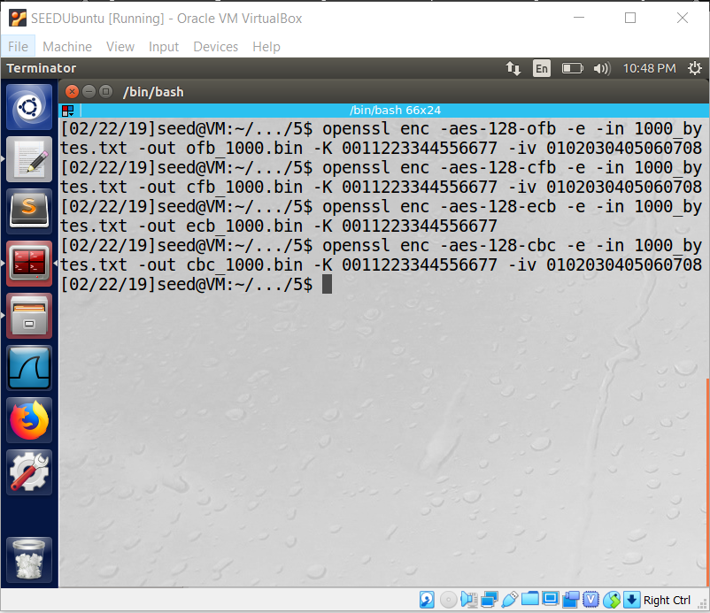

3. 1 bit Substitution in the 55th Byte

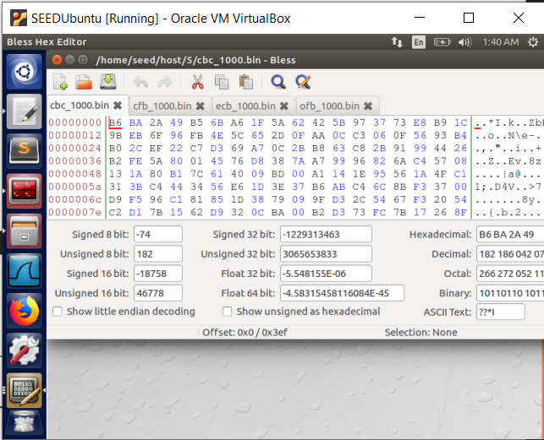 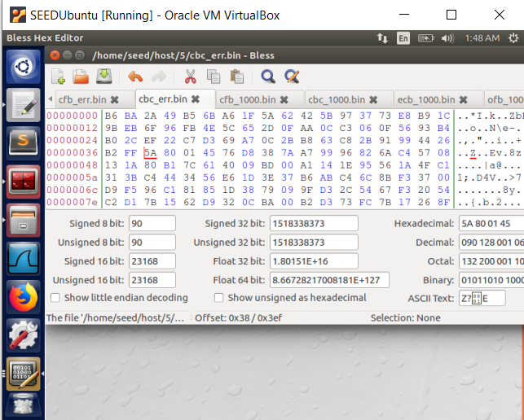

CBC 55th byte = FE = 11111110 to FF = 11111111

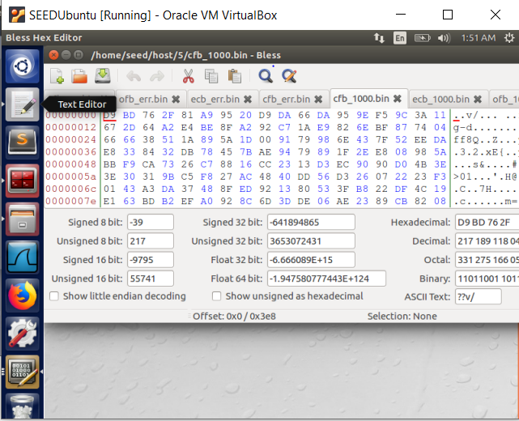 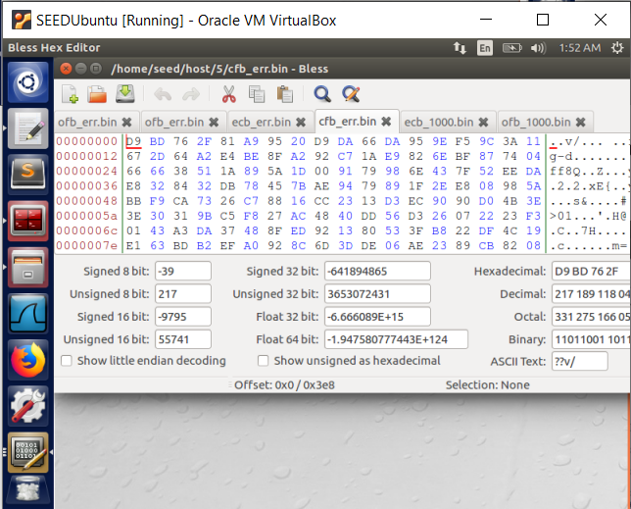

CFB 55th byte = 33 = 00110011 to 32 = 00110010

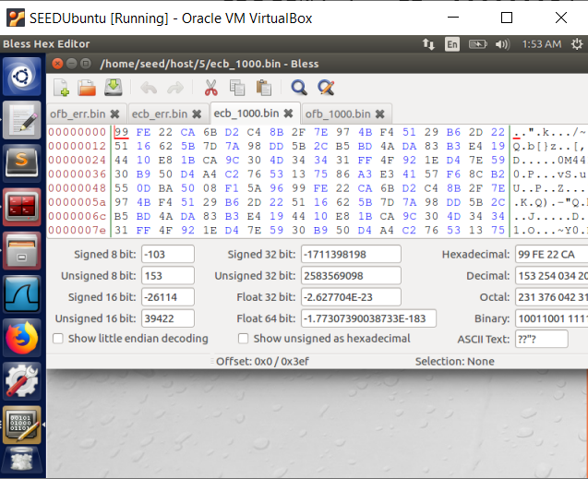 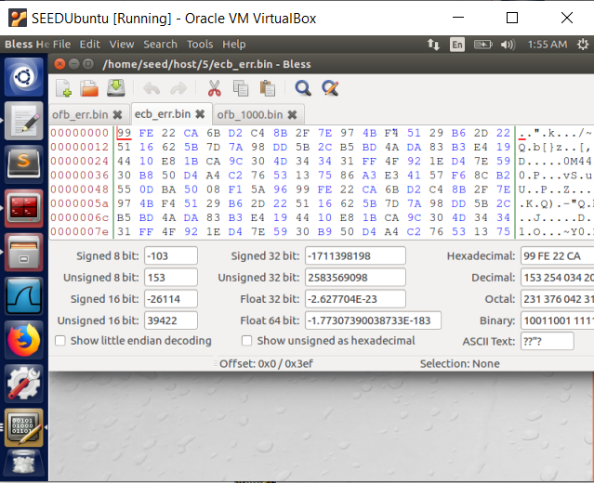

ECB 55th byte = B9 = 10111001 to B8 = 10111000

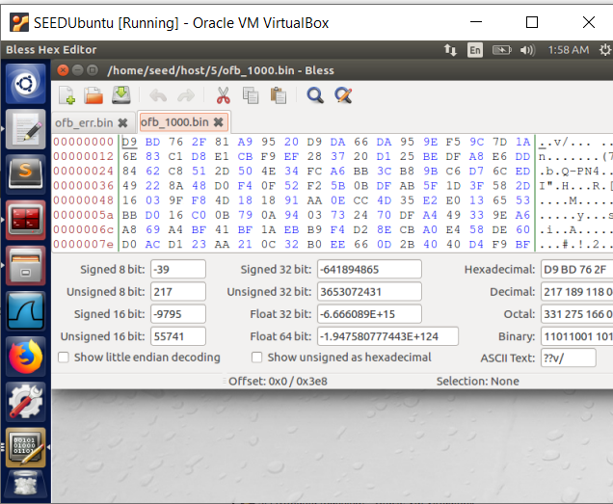 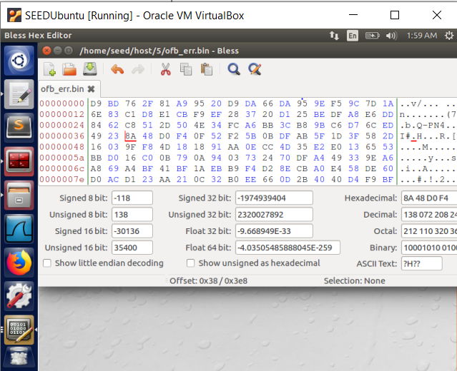

OFB 55th byte = 22 = 00100010 to 23 = 00100011

4. Decryption

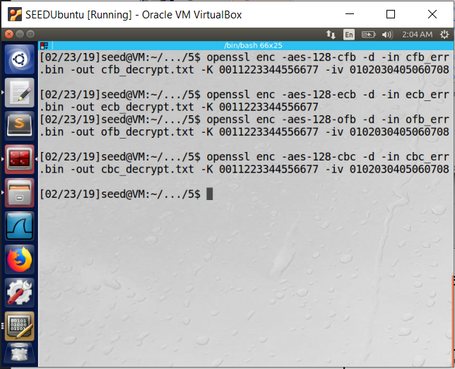

Before looking at the files:

1. CFB should produce the most error since it uses the previous ciphertext as input into the decryption of the next block. Since the error occurs in the 55th bit, the cypher will not self-synchronize until the shift and throw off n/s = 16/4 = 4 blocks of the decryption. (most unrecoverable)
2. CBC should produce the next most errors since the pervious ciphertext is used to decrypt the next block. Thus, the block the error resides and the next block will be error prone (2 blocks).
3. ECB should produce the next least errors since each ciphertext is used only for that block. Thus, the block the error resides should be corrupted (1 block).
4. OFB should produce the least error since each block is independently decrypted without the error propagating the error into incoming blocks; thus, only 1 byte should be impacted. (most recoverable 1 bit)

OFB ECB

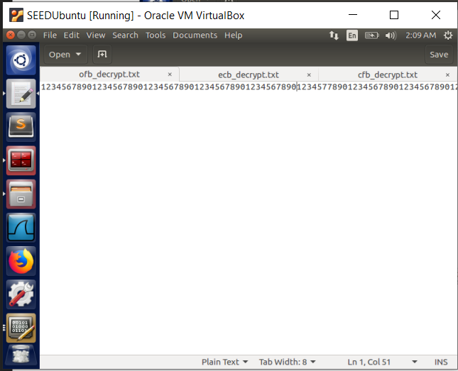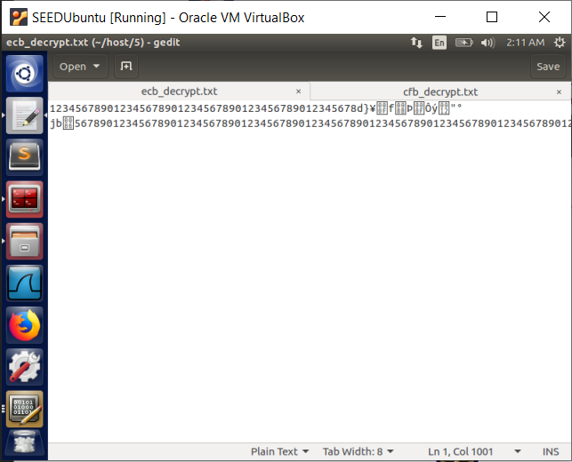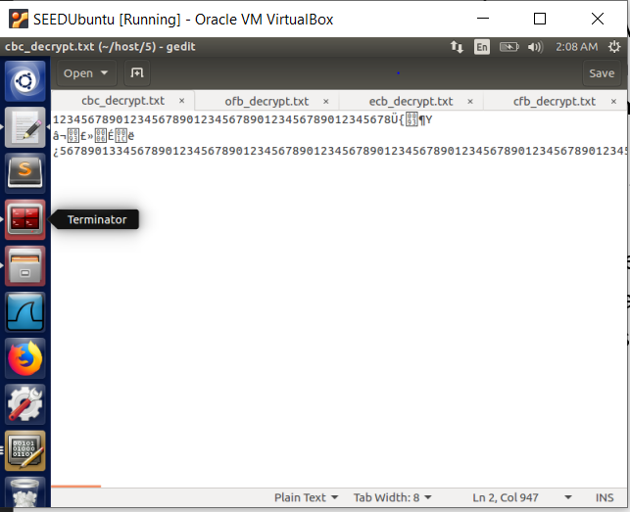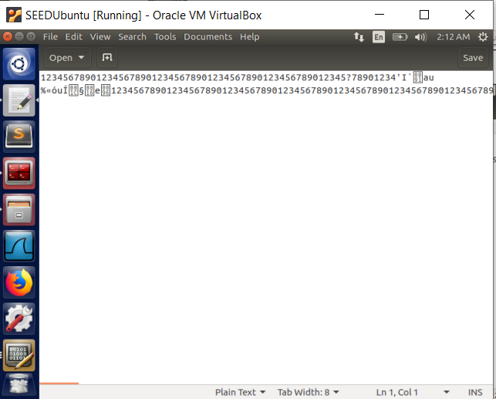

CBC CFB

As justified by previous reasoning, the decrypted text mimics the block corruption. OFB shows 1 bit change, ECB shows 1 block change, CBC shows 2 block change but CFB shows the less corruption which might be due to its synchronization ability.

* 1. Task 6: Initial Vector (IV)

1. (a) Different IVs

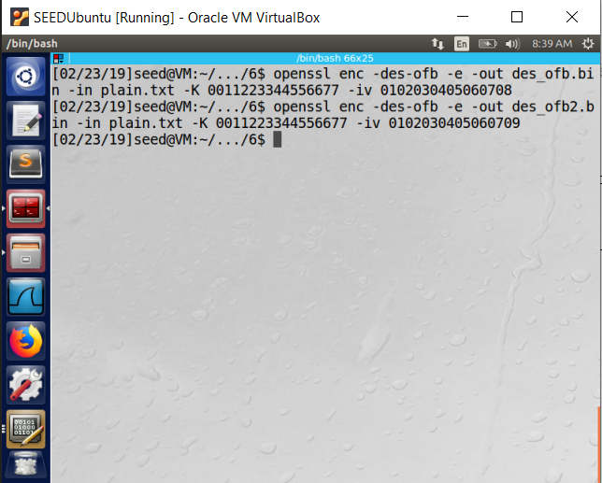 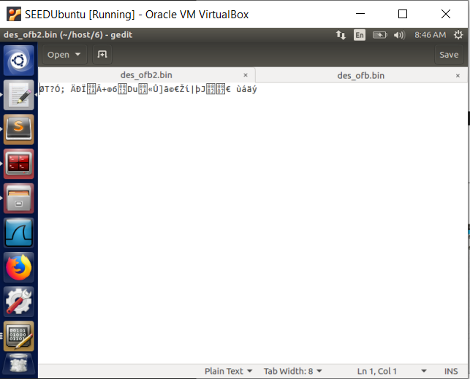 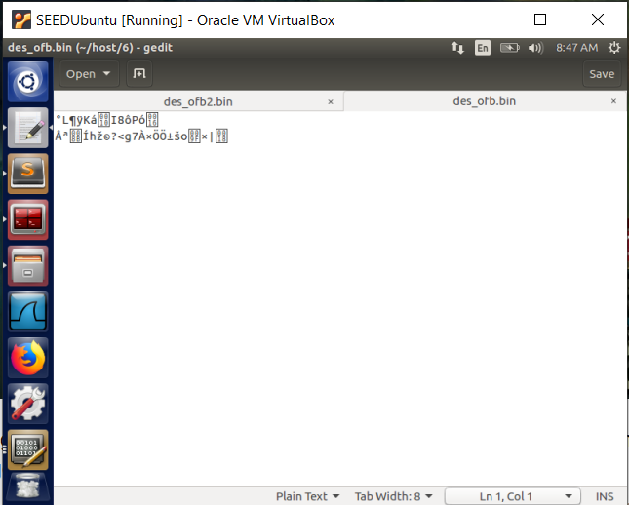

Command Different IV File Different IV File

As observed, encrypted files with different IVs look very different from each other.

(b) Same IVs

1

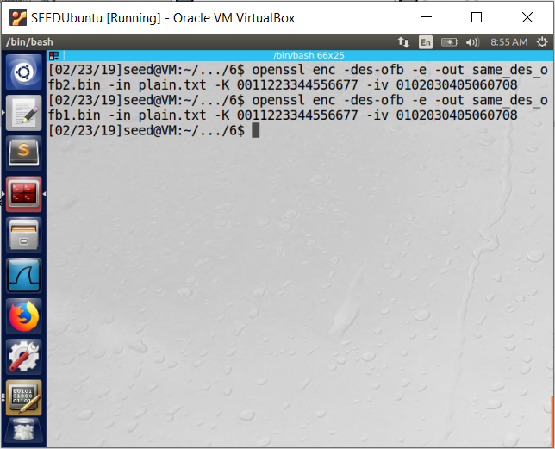 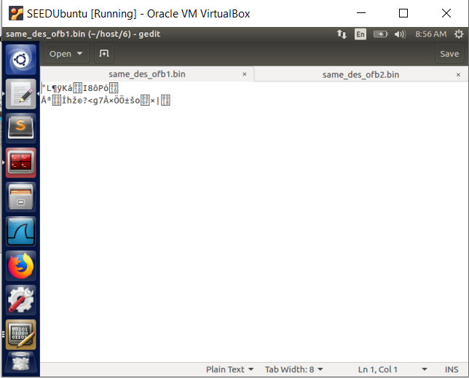 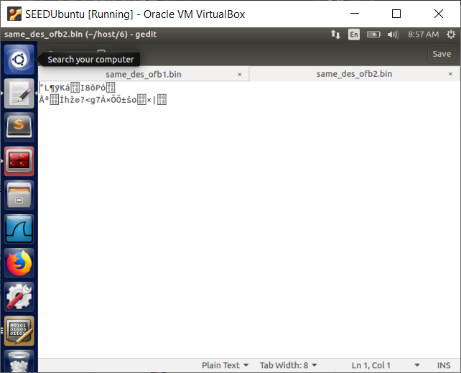

Command Same IV File Same IV File

As observed, encrypted file with same IVs look the exactly the same as each other.

1. OFB Block:

Since OFB used encrypted IV and ⊕s the Ciphertext to create the Plaintext in the decryption portion of the OFB mode, we can use this to calculate a message given P1, C1 and C2.

Thus, the formula is:

Encrypted IV ⊕ P1 = C1

Encrypted IV = P1 ⊕ C1

Encrypted IV ⊕ P2 = C2

P2 = Encrypted IV ⊕ C2

P2 = P1 ⊕ C1 ⊕ C2 = 'Order: Launch a missile!\n’ = 'Order: Launch a missile!’

CFB Block:

In CFB, XORing the plaintext and ciphertext will result in the key and IV block cipher encryption string; but the same encryption string is not used for every block (the resulting ciphertext is used. Thus, the first block can be easily be recovered but the next blocks will be harder to decipher unless block sizes and encryption algorithm is known.

1. Predictable IVS:

Key = '00112233445566778899aabbccddeeff'

IV1 = '31323334353637383930313233343536'

IV2 = '31323334353637383930313233343537'

C1 = ‘bef65565572ccee2a9f9553154ed9498’

Following CBC block mode, we can use the following formula:

P1 ⊕ IV1 = P2 ⊕ IV2 = X such that X can sent to the AES-128 algorithm and C1 = C2

Since we know that P1 can be ‘Yes’ or ‘No’, let us assume P1 = ‘Yes’:

P1 = ‘Yes’

P1_hex = ‘5965730d0d0d0d0d0d0d0d0d0d0d0d0d’

Since the blocks are 16 bytes long and Yes makes up 3 bytes, 16 - 3 = 13 = 0d will be the padding add 13 times.

Now solve for P2:

P1 ⊕ IV1 = X = P2 ⊕ IV2

0x68574039383b3a35343d3c3f3e39383b = X = P2 ⊕ IV2

P2 = X ⊕ IV2

P2 = 0x5965730d0d0d0d0d0d0d0d0d0d0d0d0c

P2 = ‘Yes\r\r\r\r\r\r\r\r\r\r\r\r\x0c’

We can ask Bob to encrypt P2 = ‘Yes\r\r\r\r\r\r\r\r\r\r\r\r\x0c’. This should yield in a C2 and we can compare with C1. If C1 = C2, then P1 = ‘Yes’, otherwise P1 = ‘No’. Using bliss, to edit a file to enter P2, we get the following:

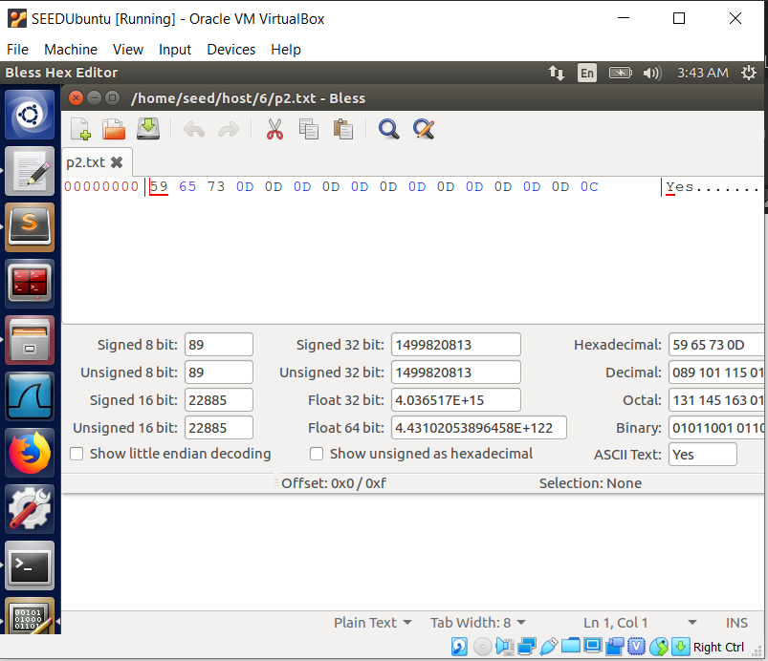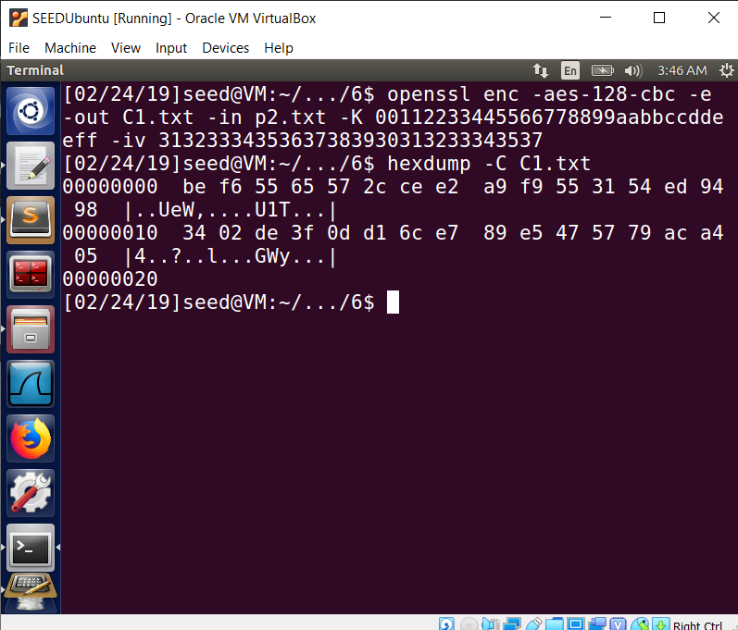

As seen, the hex dump is: be f6 55 65 57 2c ce e2 a9 f9 55 31 54 ed 94 98 for the first block. This is the same as C1 and thus results in P1 = ‘Yes’.

2.7 Task 7: Programming using the Crypto Library (EXTRA CREDIT):

1. Set the message in char []
2. Set IV as hex in char [] using 0x..
3. Set key in char [] and transform to char [] filled with integer of each character
4. Pass all arguments to EVP commands
5. Convert resulting ciphertext to char [] filled with hex without 0x
6. Compare resulting hex [] with the given ciphertext.
7. Code is more commented
8. Resulting KEY: **liquefaction**
9. Test KEY -> liquefaction = liquefaction#### = **6c6971756566616374696f6e23232323**

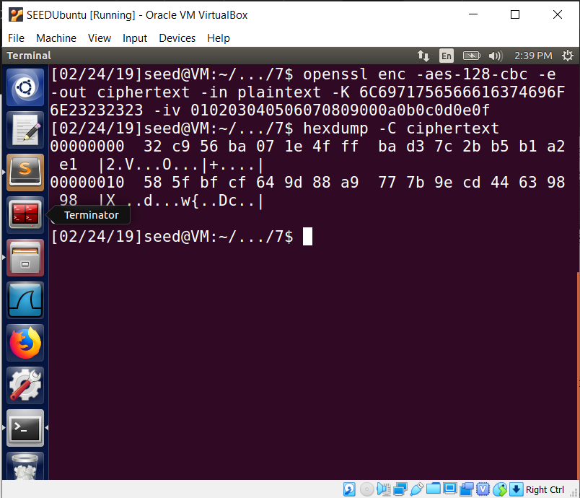

1. Resulting Ciphertext = 32c956ba07le4fffbad37c2bb5b1a2e1

585fbfcf649d88a9777b9ecd44639898 (WHICH IS A MATCH)